Meeting in Sint Maarten Adress : 209 L.B. Scott Road,
Saint-Martin (partie néerlandaise)
Telephone: + 721 548 4277
Student from:

- Lituania
- Netherlands
- Poland
- France
- Spain

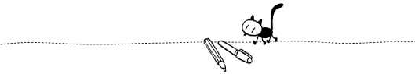
Capital letters please

Name: Surname:
Age ........
I am:

Email: Phone number:
Facebook: Instagram:
Other:
Hobbies:
IMPORTANT INFORMATION
Special diet:
Allergy: none
Religion: private
Vegetarian or vegan: no
Medical requirements:
Treatments:
Allergy:
Health problem(s):

HOST FAMILY
I’d like to stay in a family:

with a girl
with a boy

Questions?

