Studying abroad!
You are in the V6 class of Comenius College and after this school new opportunities await. One of the most important decisions you have to make in your life, is whether or not you are going to study and if so, where? This task is going to help you what it takes to find the right study for you.
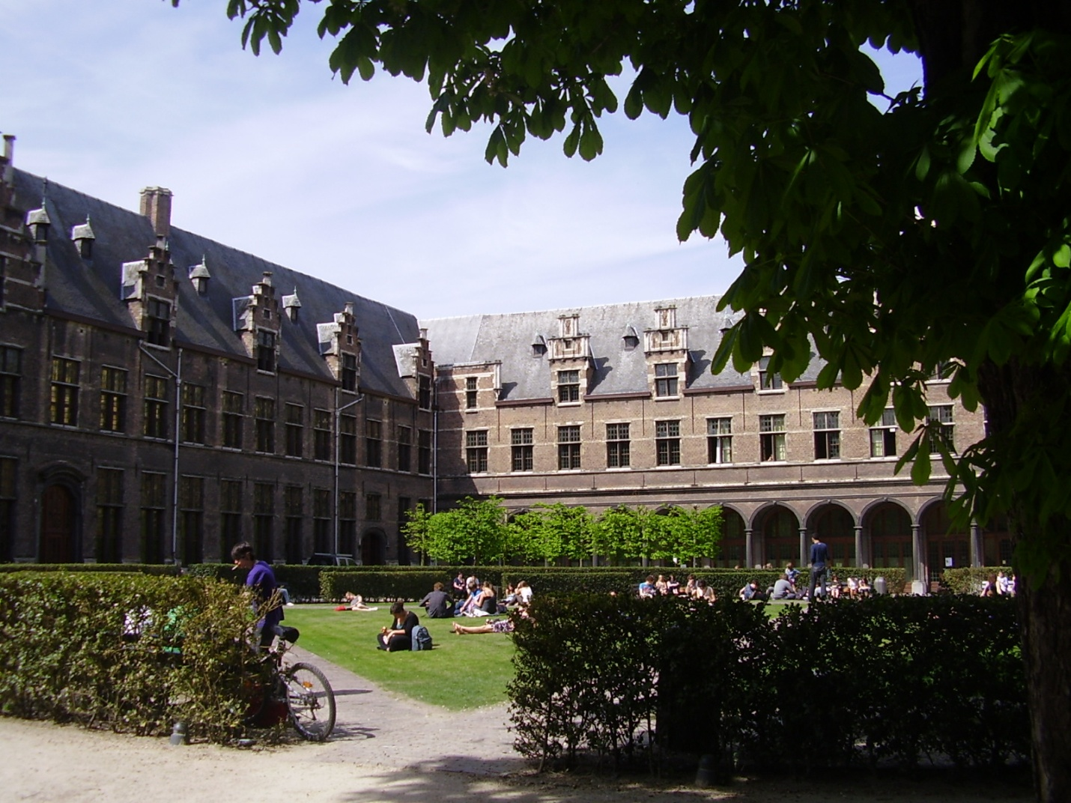
University? Higher education? What would I like to do and where is this possible?
Take the following steps:
- Choose a study of your interest. (or a field of study of your interest)
- Now choose a college (high school) or university in The Netherlands where you can do your study of interest. ( More possibilities) To get your answers: use email, too!

- Where is it possible to do the study of your interest? (more options, of course)
- What pre-education do you need to attend the college/university you found?
- Do you need certain subjects for that college/university and at which level?
- Does that college/university prefer that you have got subjects at Comenius College and if so at which level?
- Is there a numerus fixus for your study? If so, what do you have to do in such a case?
- How long does it take to complete your education at your chosen college/university?
- Do you have practical semesters in the college/university of your choice? If so, how many and how long?
- What does your new study cost per year? Include everything you can think of!
- How do you think you will pay for your study?
- What are the possibilities to get study finance support? If so, how do you apply for it? What are the rules if you apply?
- How is housing arranged at the college/university of your choice?
- How do you apply for the college/university of your choice?
- What is the final date that you can send in your application?

Find an university abroad, but not in Belgium
Now try to find the answers to these questions: (don’t only use the website as a source, but also try to get as much information as possible by email!)
- Where is it possible to do the study of your interest? (more options, of course). Look for the country you prefer.
- What pre-education do you need to attend the college/university you found?
- Do you need certain subjects for that college/university and at which level?
- Does that college/university prefer that you have got subjects at Comenius College and if so at which level?
- Is there a numerus fixus for your study at that college/university? If so, what do you have to do in such a case?
- How long does it take to complete your education at your chosen college/university?
- Do you have practical semesters in the college/university of your choice? If so, how many and how long?
- What does your new study cost per year? Include everything you can think of!
- How do you think you will pay for your study?
- What are the possibilities to get financial support? If so, how do you apply for it?
- How is housing arranged at the college/university of your choice?
- How can you apply for the college/university of your choice?
- What is the final date that you can send in your application?
- Structure it:
- Introduction
- Studying in The Netherlands.
- Studying abroad
- Which of the two diplomas is preferred if you apply for a job after your study?
- Conclusions after your investigation about your study abroad.
- The first conclusion can be an idealistic one: if you don’t have to take anything into account what will you choose?
- The second conclusion should be a realistic one: so now you take all you found into account and make your choice.
- Bibliography (your source list)
Mail your work to your teacher or hand it in on paper.

